##### TECHNO MACHINE TOOLS

Survey no:126/A/1, DOOR NO: 4-132-9/A/2, Gandimaisamma X Road,

Medchal Malkajgeri,Hyderabad-500043.Telangana, India.

**(MANUFACTURERS OF SLITTING AND CUT-TO-LENGTH MACHINES)**

**T.SIVARAMAKRISHNA**

**ME., MBA.**

-------------------------------------------------------------------------------------------------------------------------

TMT/AJAY SHARMA /S051/2025. 07.02.2025

To,

AJAY SHARMA  
Company : New Company- Ajay sharma  
Phone No :  
[91--7828207738](tel:91--7828207738)  
Mobile No :  
[+917828207738](tel:+917828207738)  
Email : [ajay@alpipl.com](mailto:ajay@alpipl.com)  
City : Neemrana  
State : Rajasthan

Dear sir,

**Sub :- Supply of 1500 MM Wide And 0.3- 1.2 MM sheet work machniery**

We thank you for your enquiry regarding cut to length machine with 1250mm wide and thickness 1.2 mm. We are glad to inform you that we would be in a position to do the required equipment as per the following specifications and descriptions of the machine along with our terms and conditions.

**Manual 5 TON decoiller**

Model : Single Arm/simply supported

Back Tension : Caliper brake,

Manually adjusted

Construction : M. S. Fabricated.

# SHEET LEVELING PINCHROLL

Number of pinch rollers : 2 Nos

Diameter of the roll : dia 80 mm

Load arrangement for pinch rolls : manual wheel

# LEVELER

Type of the machine : 2Hi

Maximum sheet width that can be leveled : 1250 MM Maximum sheet thickness in MS that can be leveled : 2.0 MM Minimum sheet thickness in MS that can be leveled : 1.2 MM Roll dia : 80 mm

No of work rolls : 7 Nos

Speed of the machine : 0-5 meters/min

Model : Crossed Beam

Drive : 7.5 HP – AC motor

The lever is with triangular roll attachment along with hydraulic screw down along with differential load indication.. The pinch roll is allowed the strip to move to forward to entry guides.

# PRICE

De coiler : Rs 4,80,000 = Rs 4,80,000 Leveler with pinchroll

unit with drive : Rs 6,80,000= Rs 6,80,000 Hydraulic shearing 1500x2.00 : Rs 3,40,000= Rs 3,40,000 Plc with automation Rs 1,80,000 = Rs 1,80,000

------------------

Total : Rs 16,80,000

-----------------

# GENERAL TERMS & CONDITIONS:

1. Price quoted per unit ex-work. Hyderabad.
2. Following charges are additional to your account.
   * Freight Charge : As actual to be borne by you.
   * Excise : Extra As Applicable at [present@12.5%](mailto:present@12.5)
   * Sales Tax : Extra as applicable@5%
   * Packing charge : As actual to be borne by you.
   * Insurance : As actual to be borne by you.
3. Payment : 50% at time of finalizing order and balance against

delivery but after inspection at our works.

1. Delivery : with in 3-4 weeks from date of advance received
2. Validity : One month from the date of submission.
3. Inspection : Inspection at our works prior to dispatch.
4. Warranty : The machine is warranted for a period of 12 months from

the date of dispatch against any manufacturing defects/ faulty material or bad workmanship of any part or component but not against any kind of abnormal or improper use of machine. Defective part or component will be replaced or repaired free of cost. Electrical components are outside the scope of this warranty.

1. Commissioning : Erection & commissioning done by you, but required technical support & guidance provide by us at additional cost.

NOTE:

1. Oil is not in scope of our supply.
2. Raw material for trial is to be arranged by you at your cost.

We are sure you will find our offer in line with your requirements. Should you require any further clarification please contact 9246221106

Thanking you and assuring you of our best services

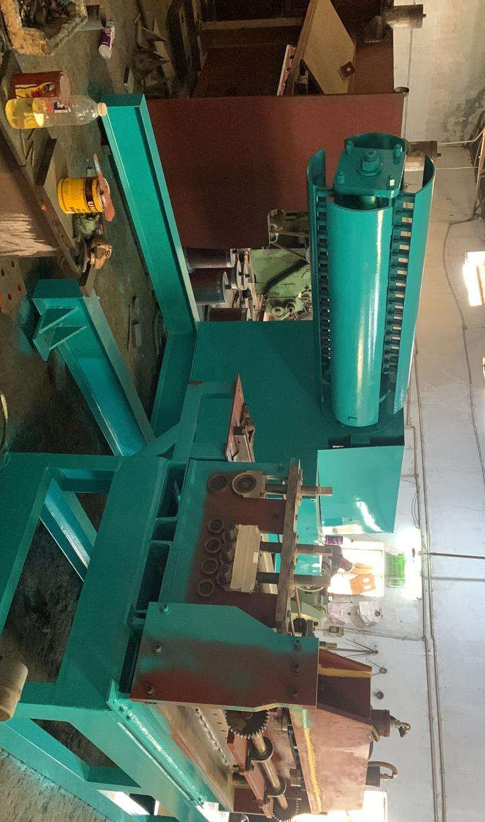

For TECHNO MACHINE TOOLS

( T. SIVARAMAKRISHNA)